BASICS OF WORD 2007
In this section we will discuss the basic layout of Word 2007 to make it easy and more useful for the users.
Microsoft Office Button
Microsoft Office button is in the upper-left corner of the Word 2007 window. On clicking the button, a menu appears. This menu can be used to create a new file, open an existing file, save a file, and perform many other tasks.
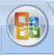

Quick Access Toolbar
The Quick Access toolbar lies next to the Microsoft Office button. It lets us access the frequently used commands. By default Save, Undo, and Redo appear on the Quick Access toolbar.
Title Bar
The Title bar next to the Quick Access toolbar displays the title of the document on which we are currently working.
The Ribbon
In Microsoft Word 2007, we use the Ribbon to issue commands that tell Microsoft Word what to do. The Ribbon lies just below the Quick Access toolbar. Tabs at the top of ribbon contain related command groups. Clicking these tabs enables us to access menus and dialog boxes.
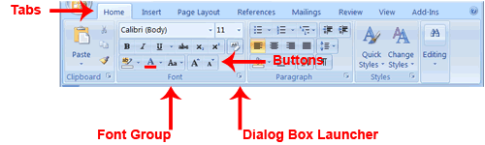
The Ruler
The ruler is found below the Ribbon.
We can use the ruler to change the format of our document quickly.
The Status Bar
At the very bottom of window appears the Status bar and provides the information about current page and the number of words in our document. Right-clicking on the Status bar and selecting the options from the Customize Status Bar menu lets us change what displays on the Status bar.
